Executive Summary
This report examines Jubilee Superstore’s business performance through two integrated components: a financial analysis dashboard and a strategic Balanced Scorecard (BSC) framework.
Part A presents an interactive dashboard that visualises profitability across products, regions, and channels. The analysis shows strong operational efficiency, achieving a 30.1% operating margin against a 16% target. However, the gross margin remains low at 18.8%, suggesting supplier cost pressure and discounting challenges. Technology and Home Office divisions lead profitability, while eastern coastal cities like Gold Coast and Hobart emerge as high-performing areas. Improving procurement and pricing policies is recommended to lift overall profitability.
Part B extends performance evaluation beyond finance. Jubilee’s customised BSC introduces six perspectives—Learning & Growth, Internal Process, Customer, Social, Environmental, and Indigenous Data Sovereignty & Ethics—to capture both tangible and ethical dimensions of performance. Twelve KPIs are proposed to align daily operations with strategic goals of reconciliation, ESG risk mitigation, and sustainable value creation.
Together, the analysis and BSC plan provide Jubilee with a balanced, future-focused framework that links financial strength with social responsibility and long-term stakeholder trust.

Part A: Financial Analysis Dashboard
This interactive dashboard visualises Jubilee Superstore’s financial performance for November 2024 across multiple dimensions. It enables management to evaluate profit margins against strategic targets and identify operational improvement areas.

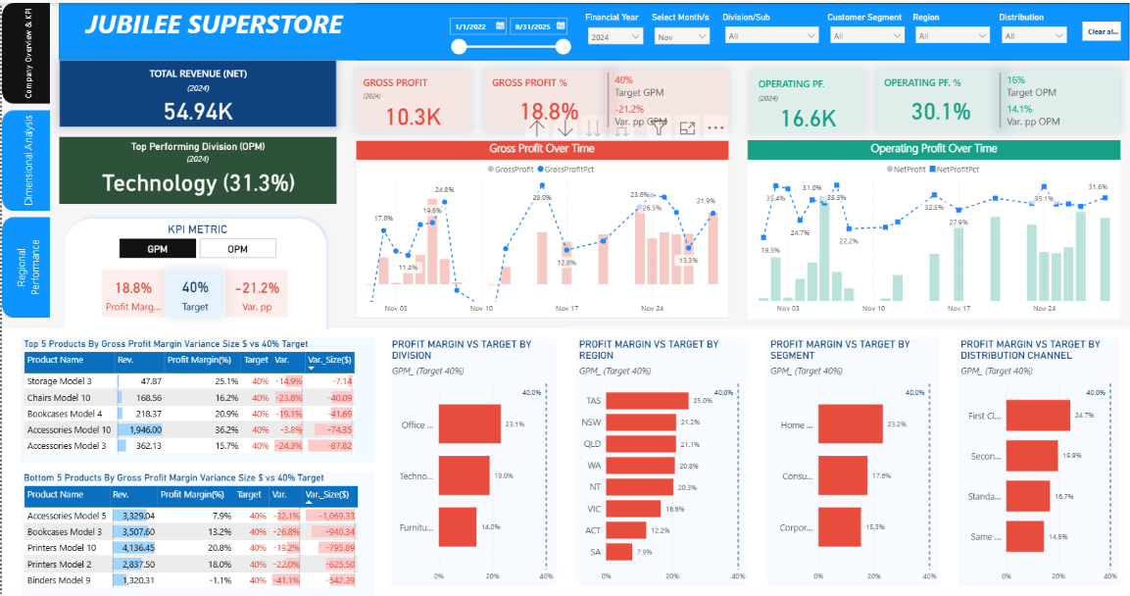
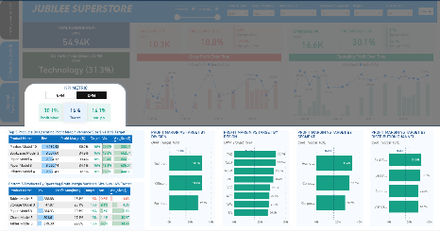
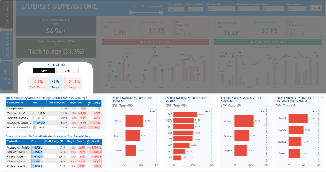
Dashboard 1: KPI Overview Page
Figure 1: Jubilee's Overall Performance & KPI Target (MTD_Nov2024)
Figure 2b: OPM View after toggle selection
Figure 3a: Default GPM View

The first dashboard provides an executive snapshot of profitability (Figure1). KPI cards summarise revenue, COGS, gross profit, and operating profit, allowing managers to assess performance instantly. A dual-axis trend chart tracks GPM and OPM across the month, revealing short-term fluctuations and seasonal trends.
To improve readability, colour logic is applied, green for metrics above target and red for below, helping decision-makers identify issues quickly without overloading information. The GPM/OPM toggle (Figures 1a–1b) allows seamless switching between cost-efficiency and operational-efficiency views. All visuals refresh dynamically to ensure consistent, real-time monitoring of company performance.

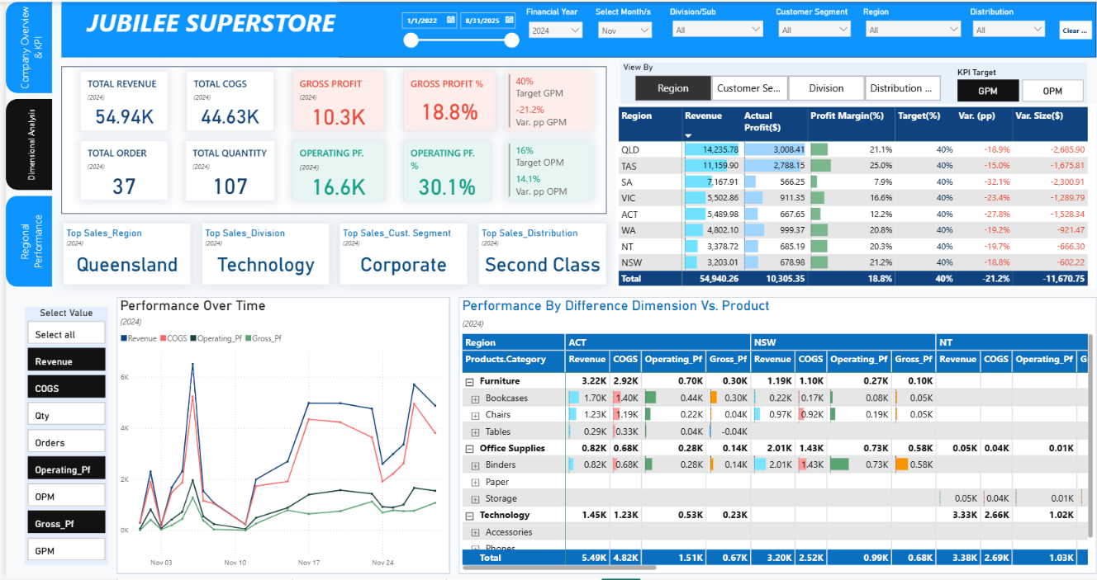
Dashboard 2: Dimensional Analysis & Performance Comparison
Figure 2: Dashboard2: Dimensional Analysis & Performance Comparison (MTD_Nov2024)

The second dashboard expands the analysis by comparing profitability across Region, Division, Customer Segment, and Distribution Channel. Summary cards and Top Sales visuals highlight key contributors at a glance. The comparison table integrates Revenue, Profit, Margin, and Variance, with parameter toggles enabling users to alternate between GPM and OPM for any dimension.
An interactive metric table and trend chart further support exploration across measures such as Revenue, COGS, Quantity, and Orders. Embedded data bars provide immediate scale awareness, while a hierarchical drill-down from Product Category to Subcategory and Product Name allows root-cause analysis. This structure transforms static data into an interactive, analytical environment that helps managers uncover inefficiencies and growth opportunities.

Dashboard 3: Regional and City-Level Performance Analysis
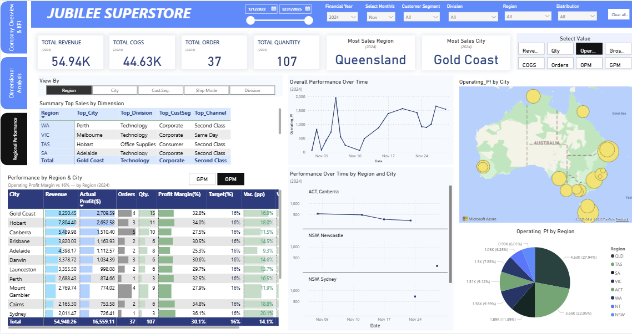
Figure 4: Dashboard3 - Regional and City-Level Performance Analysis
The final dashboard adds a geospatial and comparative lens to the story. It translates earlier profitability findings into regional and city intelligence that highlights where performance occurs. The summary table ranks top cities, divisions, segments, and channels, giving an instant view of high-value combinations. The city-level metric table enables direct GPM/OPM comparison across markets, while trend lines and small multiples reveal regional trajectories over time.
An interactive map and parameter-linked pie chart connect financial outcomes with spatial context, turning quantitative results into visually rich business insight. This page completes the system by integrating financial, operational, and geographic perspectives for strategic planning.

Key Insights and Financial Performance Analysis
The dashboards collectively reveal that Jubilee Superstore achieved $54.9K in revenue and a 30.1% Operating Profit Margin (OPM), exceeding the 16% target, but only an 18.8% Gross Profit Margin (GPM), below the 40% goal. This indicates strong operational efficiency but ongoing sourcing and pricing challenges.
The Technology Division leads profitability (31.3% OPM), driven by high-margin products like Printers and Accessories. Home Office customers deliver the best returns (33.4% OPM), confirming that smaller, recurring purchases outperform large contracts. Second-Class delivery also achieves efficient performance (30.8% OPM), balancing cost and delivery speed.
Regionally, Queensland and Tasmania exceed 32% OPM, with Gold Coast and Hobart emerging as profit centers. Sydney and Cairns record high percentage margins (above 34%) but lower absolute profit, showing strong efficiency at limited scale. Profitability clusters along the eastern coast, where demand density aligns with delivery routes.
The low GPM suggests discounting impacts gross profit more than operations. Management should review discount policies and supplier negotiations to preserve margins while maintaining competitiveness.
Overall, Jubilee demonstrates robust operational control and financial discipline. To reach its 40% GPM target, it must enhance cost management and pricing strategy. The dashboards transform complex financial data into concise, evidence-based insights that guide sustainable and profitable growth.

Part B – BSC Plan Development

Introduction
Jubilee Superstores Ltd is an Australian retailer of electronics, books, and office supplies. The company previously focused on financial growth but has now expanded its evaluation framework to reflect sustainability and ethics. It integrates Environmental, Social, and Governance (ESG) indicators, social responsibility, and Indigenous Data Sovereignty into its performance model. The strategic objectives are to strengthen relationships with Aboriginal and Torres Strait Islander peoples, mitigate environmental and social risks, and build long-term value through transparency and accountability. To achieve these goals, Jubilee applies the Balanced Scorecard (Kaplan & Norton, 1992) to measure progress across six perspectives.

2. Balanced Scorecard Design Overview
The Balanced Scorecard (BSC) translates an organisation’s vision into measurable objectives through four traditional perspectives: financial, customer, internal process, and learning and growth.
For Jubilee Superstores Ltd, the BSC is customised to focus on non-financial performance, reflecting its shift from profit orientation to sustainability and accountability. To align with strategic goals in reconciliation, ESG risk mitigation, and long-term value creation, Jubilee extends the framework to six perspectives by adding Social Performance, Environmental Sustainability, and Indigenous Data Sovereignty & Ethics.
This integrated structure enables Jubilee to assess outcomes holistically, capturing efficiency, social impact, environmental responsibility, and ethical data governance. Figure 4 below illustrates how these perspectives collectively form an integrated framework for sustainable business success.
Figure 4 - illustrates the integrated cause-and-effect relationship across six perspectives, demonstrating how ethical, social, and environmental KPIs collectively support Jubilee’s strategic objectives of reconciliation, ESG risk mitigation, and sustainable growth.

3. KPI Development and Justification
Jubilee’s Balanced Scorecard (BSC) has been designed around a cause-and-effect logic where learning and growth build operational capability, operational capability drives customer satisfaction, customer trust enables social investment, social commitment fosters environmental stewardship, and environmental responsibility reinforces ethical governance.
Together, these twelve Key Performance Indicators (KPIs) form a single chain linking everyday practice to the company’s three strategic objectives: (1) to strengthen relationships with Aboriginal and Torres Strait Islander peoples through reconciliation and ethical data governance, (2) to mitigate environmental and social risks through sustainable operations, and (3) to create long-term stakeholder value through transparency and accountability.
- Learning and Growth
Employee capability and engagement provide the foundation for every other perspective in the BSC.
The first KPI, Average Training Hours per Employee, measures the company’s investment in human capital and ethical competence. It is computed as total completed training hours ÷ number of employees. Training programs include cultural-safety workshops, Indigenous Data Sovereignty (IDSov) principles, and technical process modules. According to Becker et al. (2001), systematic learning increases organisational resilience and performance consistency. Training logs, certification records, and course attendance data will be drawn from the learning-management system to monitor participation and coverage. A strong focus on data ethics and cultural awareness ensures that staff act responsibly when handling Indigenous information and when interacting with diverse communities.
The second KPI, Employee Engagement Score, evaluates the emotional and cognitive commitment of staff to Jubilee’s mission. It is calculated as positive responses on engagement items ÷ total responses × 100 percent. Data will come from biannual anonymous surveys, open-text feedback, and turnover statistics. High engagement reflects not only morale but also alignment with the company’s reconciliation values and sustainability mindset. Together, training and engagement translate ethical intention into consistent daily behaviour. Motivated and skilled employees execute operations efficiently, minimise errors, and deliver the reliable service that sustains customer trust.
- Internal Process Efficiency
Operational excellence is captured by two KPIs in the Internal Process Efficiency perspective. The first, Order Fulfilment Cycle Time, measures the average elapsed time from order date to delivery, formulated as Σ(delivered date − order date) ÷ number of orders. Shorter cycle times demonstrate responsive coordination between departments and effective resource use. Enterprise-resource-planning (ERP) timestamps and transport-management data provide continuous monitoring.
The second KPI, Inventory Accuracy Rate, measures stock reliability through number of SKUs where system quantity = physical count ÷ total SKUs × 100 percent. Accurate inventory avoids stockouts, markdowns, and unnecessary replenishment, improving both cost efficiency and environmental outcomes by reducing waste shipments. Data are collected from RFID records, cycle counts, and variance reports. These two process KPIs translate staff capability into measurable productivity gains, linking internal efficiency to the customer experience that follows.
- Customer Satisfaction
Customer outcomes complete the first causal chain. The Customer Satisfaction Index (CSI) is computed as average post-purchase rating ÷ maximum rating × 100. High CSI values indicate that operational reliability and fairness in service recovery are being recognised by consumers. Data are drawn from point-of-sale surveys, email feedback, and complaint ratios stored in the CRM. Complementing this, the Net Promoter Score (NPS), percentage of promoters (9–10) minus percentage of detractors (0–6), assesses advocacy behaviour. According to Fornell et al. (1996) and Kaplan and Norton (1996), satisfaction and advocacy are leading indicators of sustainable value creation. Surveys are administered after transactions, combining numeric scores with qualitative reasons for promotion or detraction.
Together, CSI and NPS close the first loop: capable, engaged employees enable efficient operations, which deliver positive customer experiences that in turn build ethical brand equity and long-term loyalty.
- Social Performance
Customer trust provides the social licence and financial capacity for Jubilee to invest back into the communities it serves. The Community Investment Ratio, defined as total community contributions ÷ net profit × 100, measures the extent of reinvestment in education, reconciliation, and local development projects. A higher ratio demonstrates Jubilee’s commitment to shared value, the principle that corporate competitiveness and social progress reinforce each other (Porter & Kramer, 2011). Expenditure data and program budgets from annual financial statements will be consolidated to monitor this contribution.
Complementing it, the Indigenous Supplier Spend Percentage assesses inclusive procurement, calculated as expenditure on Indigenous suppliers ÷ total procurement × 100. This KPI captures Jubilee’s economic contribution to reconciliation by supporting Aboriginal and Torres Strait Islander businesses (Reconciliation Australia, 2021). Procurement ledgers and supplier-classification databases such as Supply Nation will verify spending proportions. Together, these two KPIs transform customer-driven brand equity into tangible community value. Satisfied customers become brand advocates whose purchases finance social investment, while community engagement strengthens stakeholder trust, creating a virtuous cycle between market performance and social inclusion.
- Environmental Sustainability
Effective social partnerships often cultivate stronger environmental awareness. Through collaboration with Indigenous and local suppliers, Jubilee integrates traditional ecological knowledge and community insights into its environmental management. The first KPI in this perspective, Carbon Emissions per Store, calculates operational intensity as (Scope 1 + Scope 2 emissions in tCO₂e) ÷ number of stores. Reducing this figure by at least 10 percent year-on-year aligns with ISO 14001 principles of continual improvement and risk control. Monthly energy bills, fuel consumption logs, and verified emission factors provide the dataset for analysis. Lowering carbon intensity reduces both environmental impact and transition risk while identifying best-practice branches for replication.
The second KPI, Waste Recycling Rate, measures resource recovery efficiency through recycled waste ÷ total waste × 100 percent. Achieving a target of 80 percent or above indicates progress toward a circular-economy model and compliance with waste-management regulations. Data are gathered from vendor weight tickets, recycling receipts, and contamination reports. By linking social cooperation to environmental performance, Jubilee ensures that community investment is not symbolic but operationally connected to sustainable resource use and long-term cost savings.
- Indigenous Data Sovereignty and Ethics
Environmental responsibility naturally extends to respect for data and cultural sovereignty. The first KPI in this perspective, Free, Prior and Informed Consent (FPIC) Compliance Rate, measures the percentage of Indigenous-related projects that obtain formal consent before any data use: number of projects with documented FPIC ÷ total Indigenous projects × 100. Achieving full compliance protects Jubilee from legal and reputational risk while demonstrating ethical reciprocity (AIATSIS, 2020). Data are drawn from signed consent forms, consultation minutes, and audit trails recorded within project management systems.
The second KPI, CARE Compliance Index, evaluates adherence to the four principles of Collective Benefit, Authority to Control, Responsibility, and Ethics (Carroll et al., 2020). Each principle is rated 0–100 based on evidence such as benefit-sharing agreements, data-access approvals, and cultural-protocol documentation, then averaged to yield a single score. This KPI transforms abstract governance commitments into quantifiable accountability. A high CARE index signifies that Jubilee manages data on Indigenous terms, reinforcing reconciliation through transparency and mutual trust.
Together, FPIC and CARE compliance represent the ethical apex of Jubilee’s cause-and-effect chain. Environmental stewardship establishes the moral consistency that underpins responsible data practice, while ethical data governance closes the feedback loop by enabling culturally appropriate environmental and social initiatives in the future. This final perspective therefore embodies the organisation’s ultimate strategic intent: using information and influence ethically to sustain relationships, manage risk, and create shared value
References
AIATSIS (2020). Code of Ethics for Aboriginal and Torres Strait Islander Research. Canberra: Australian Institute of Aboriginal and Torres Strait Islander Studies.
Becker, B., Huselid, M., & Ulrich, D. (2001). The HR Scorecard: Linking People, Strategy, and Performance. Harvard Business School Press.
Carroll, S. R., et al. (2020). The CARE Principles for Indigenous Data Governance. Data Science Journal, 19(1), 43.
Fornell, C., Johnson, M. D., Anderson, E. W., Cha, J., & Bryant, B. E. (1996). The American Customer Satisfaction Index: Nature, Purpose, and Findings. Journal of Marketing, 60(4), 7–18.
ISO (2015). ISO 14001: Environmental Management Systems — Requirements with Guidance for Use. International Organization for Standardization.
Kaplan, R. S., & Norton, D. P. (1996). The Balanced Scorecard: Translating Strategy into Action. Harvard Business Press.
Porter, M. E., & Kramer, M. R. (2011). Creating Shared Value. Harvard Business Review, 89(1–2), 62–77.
Reconciliation Australia (2021). Reconciliation Action Plan Framework. Canberra: Reconciliation Australia.
Slack, N., Chambers, S., & Johnston, R. (2013). Operations Management (7th ed.). Pearson Education.

Reference:
Kaplan, R. S., & Norton, D. P. (1992). The Balanced Scorecard—Measures That Drive Performance. Harvard Business Review. The Balanced Scorecard—Measures that Drive Performance

